**Practical No 6**

**Aim :** Develop, debug and Execute a C program to simulate the Round Robin CPU scheduling algorithms to find turnaround time and waiting time.

**Apparatus:** Computer system with windows installed in it.

Mingw compiler for C/C++, and a text editor for developing C code file (Dev C++).

**Theory :**

**What is RR scheduling?**

* RR is short for ‘Round Robin’ Scheduling algorithm.
* This algorithm is designed especially for time sharing systems.
* It is similar to FCFS scheduling, but preemption is added to enable the system to switch between processes.
* A small unit of time, called a time quantum, or time slice, is defined. A time quantum is generally from 10 to 100ms in length.
* To implement RR scheduling, we treat the ready queue as a FIFO queue of processes.
* The performance of the RR algorithm depends heavily on the size of the time quantum.
* Every process is allocated no more than 1 time quantum in a row, unless it is the only process in the ready queue.
* To implement RR scheduling, we treat the ready queue as a FIFO queue of processes.
* One of the two scenarios can arise when interrupt occurs:
  + The process may have a burst time less than that of 1 time quantum, in this case the process itself will release the CPU voluntarily.
  + If the CPU burst of the current running process is longer than 1 time quantum, the timer will go off and cause an interrupt to the operating system. A context switch will be executed, and the process will be pout at the tail of the ready queue.
  + The CPU scheduler will then select the next process in the ready queue.

**What is a Time Quantum?**

* A time quantum is defined as a small unit of time or a time slice.
* A time quantum is generally from 10 to 100ms in length.
* The performance of the RR algorithm depends heavily on the size of the time quantum.
  + If the quantum is extremely large, the RR policy is the same as the FCFS policy.
  + If the quantum is extremely small (e.g. 1ms), the RR approach can result in a large number of context switches.
* We want the time quantum to be large with respect to the context switch time.
* If the context-switch time is approximately 10 percent of the time quantum, then about 10% of the CPU time will be spent in context switching.
* Most computing systems have a time quantum ranging from 10ms to 100ms.
* The time required for a context switch is typically less than 10 microseconds.
* Thus, the context-switch time is a small fraction of the time quantum

**Example :**

|  |  |
| --- | --- |
| **Process** | **Burst Time** |
| **P1** | **24** |
| **P2** | **3** |
| **P3** | **3** |

|  |  |  |  |  |  |  |  |
| --- | --- | --- | --- | --- | --- | --- | --- |
| P1 | P2 | P3 | P1 | P1 | P1 | P1 | P1 |

0 4 7 10 14 18 22 26 30

Waiting time for p1 = (10-4) = 6

Waiting time for p2 = 4

Waiting time for p3 = 7

Average waiting time =p1 + p2 + p3 / 3

= (6 + 4 + 7)/ 3

= 17/4

= 5.67ms

Turnaround time for p1 = 30ms

Turnaround time for p2 = 7ms

Turnaround time for p3 = 10ms

Average turnaround time = 30 + 7 + 10 / 3

= 47 / 3

= 15.67ms

**Code:**

#include<stdio.h>

#define true 1

#define false 0

void CalculateWaitingTime(int size, int burstTime[], int waitingTime[],int timeQuantum){

  int burstTimeRemaining[size];

  for(int i = 0; i < size; i++){

    burstTimeRemaining[i] = burstTime[i];

  }

  int time = 0;

  int flag = true;

  while(flag){

    int done = true;

    for(int i = 0; i < size; i++){

      if(burstTimeRemaining[i] > 0){

        done = false;

        if(burstTimeRemaining[i] > timeQuantum){

          time += timeQuantum;

          burstTimeRemaining[i] -= timeQuantum;

        }else{

          time = time + burstTimeRemaining[i];

          burstTimeRemaining[i] -= burstTimeRemaining[i]; ///

          waitingTime[i] = time - burstTime[i];

        }

      }

    }

    if(done == true){

      flag = false;

    }

  }

}

void CalculateTurnAroundTime(int turnAroundTime[],int waitingTime[], int burstTime[],int size){

  for(int i = 0; i <size; i++){

    turnAroundTime[i] = waitingTime[i] + burstTime[i];

  }

}

void println(char ch){

  for(int i = 0; i < 68 ; i++)

    printf("%c",ch);

  printf("\n");

}

void CalculateAverageTime(int process[], int size, int burstTime[], int timeQuantum){

  int waitingTime[size];

  int turnAroundTime[size];

  float totalWaitingTime = 0, totalTurnAroundTime = 0;

  CalculateWaitingTime(size,burstTime,waitingTime,timeQuantum);

  CalculateTurnAroundTime(turnAroundTime,waitingTime,burstTime,size);

  for(int i = 0; i < size; i++){

    totalWaitingTime += waitingTime[i];

  }

  for(int i = 0; i < size; i++){

    totalTurnAroundTime += turnAroundTime[i];

  }

  system("cls");

  printf("\t");

  println('_');

  printf("\t|Process ID\t|Burst Time\t|Waiting Time\t|Turn Around Time |\n");

  for(int i = 0; i < size; i++ ){

    printf("\t|%5d\t\t|%5d\t\t|%5d\t\t|%10d\t |\n",process[i],burstTime[i],waitingTime[i],turnAroundTime[i]);

  }

  totalTurnAroundTime = totalTurnAroundTime/(float) size;

  totalWaitingTime = totalWaitingTime/(float) size;

  printf("\n\tTotal Turnaround Time : %.3fms\n",totalTurnAroundTime);

  printf("\tTotal Waiting Time : %.3fms\n",totalWaitingTime);

}

void input(int arr[], int n, char* name){

  for(int i = 0; i<n; i++){

    printf("%s %d : ",name,i+1);

    scanf("%d",&arr[i]);

  }

}

int main(){

  int sizeOfProcess;

  int timeQuantum;

  printf("Enter number Of Process : ");

  scanf("%d",&sizeOfProcess);

  int process[sizeOfProcess];

  int burstTime[sizeOfProcess];

  input(process,sizeOfProcess,"Process id (Integer) for process");

  input(burstTime,sizeOfProcess,"Burst time (seconds) : ");

  printf("Input time quantum (in milliseconds): ");

  scanf("%d",&timeQuantum);

  CalculateAverageTime(process,sizeOfProcess,burstTime,timeQuantum);

  return 0;

}

**Output**:

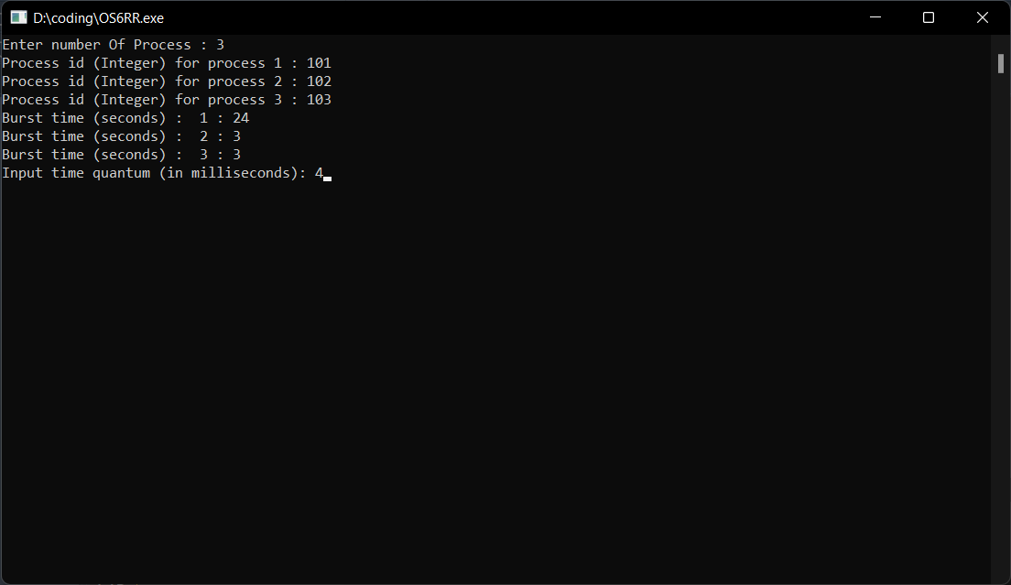

Output 6.1. Inputting Data

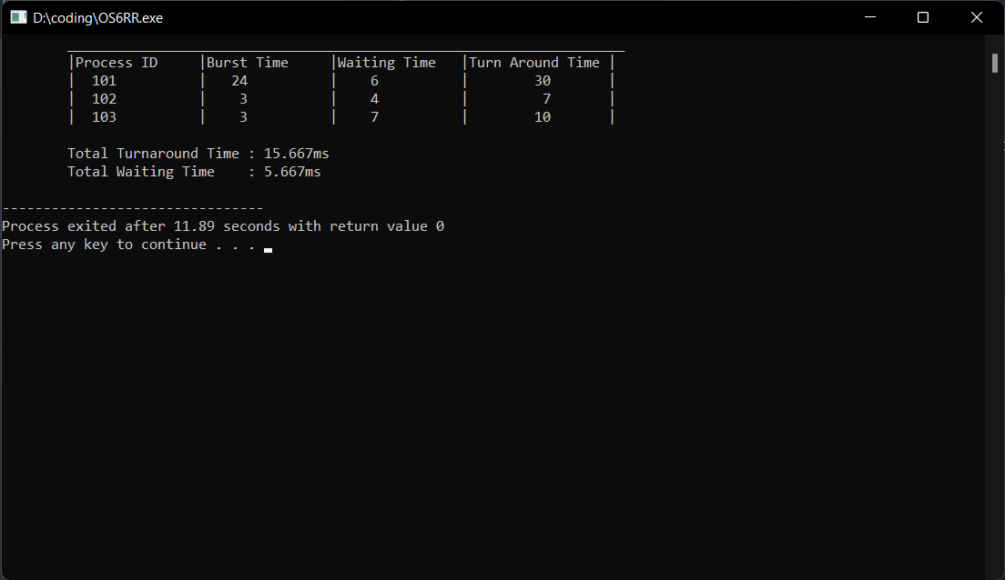

Output 6.2. Displaying Result

**Conclusion**:

Hence, by performing this practical I got to know about the concept of Round Robin Scheduling Algorithm, which is almost like First-come, First-serve scheduling but with Preemption added to it by using Time Quantum for preempting processes after exactly 1 time quantum. I also developed, debugged and executed a c program to simulate the Round Robin CPU scheduling algorithm and found out the turnaround time and the waiting time using the program.